Lecturer’s name: N/A | Date: Day 3
Course: Math 6 | Unit: Operations with Positive Fractions and Decimals
Unit Duration: 10 | Lesson Duration: 2 days
TEKS: 6.3ER | Lesson Part #1
Topic: Dividing Decimals Day 1

Lesson objectives:
- I can write division problems three different ways.
- I can use the terms: dividend, divisor, and quotient correctly.
- I can explain why writing remainders in fraction form can be more efficient than writing them in decimal form.
- I can interpret remainders in terms of a problem situation.
- I can divide decimals

Essential Questions:
- In what other ways can the remainder be written besides just the “R”?
- Can a reminder be written as a fraction?

LYS Methodology
Be (Character/Values/Principles) - How does dividing values help me be more disciplined and dedicated?

Know (What resources are available to the student/ How can they use them) - Knowing and understanding the steps with division mathematically can help students understand the importance of resourcefulness, setting boundaries, and assertiveness

Do (Execute with Excellence) - Dividing values will help students be more driven while managing values and opportunities

Resources (Include Technology):
Instructional Input - Asynchronous
AS: Anticipatory Set (Introduction)
- Students practice long division with NO remainders. As students are practicing, ensure to be circulating and monitor students are dividing correctly using the long division method. Bring class together if the same mistake continues to happen to review whole class
M: Modeling (I do)
- Teacher MODELS example 1
- 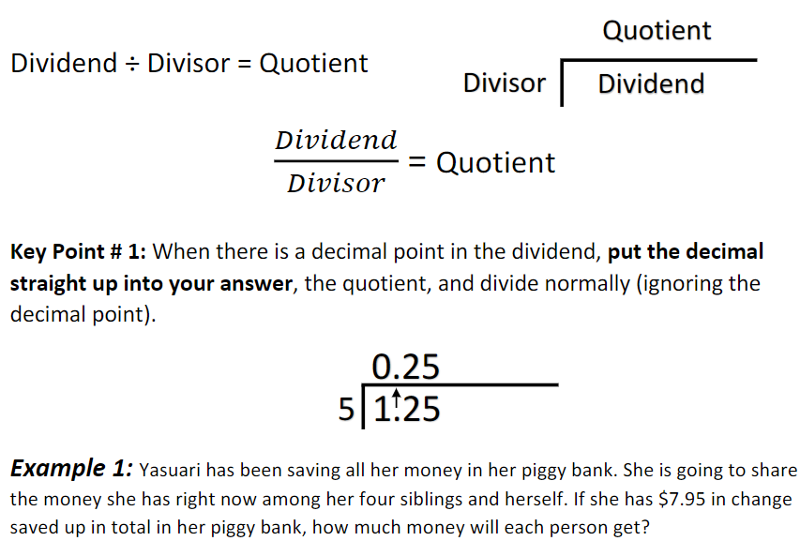

- Students complete example 2
- 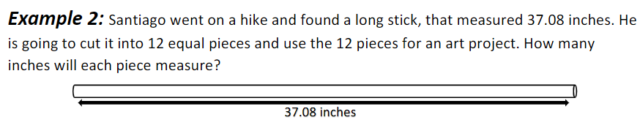

- 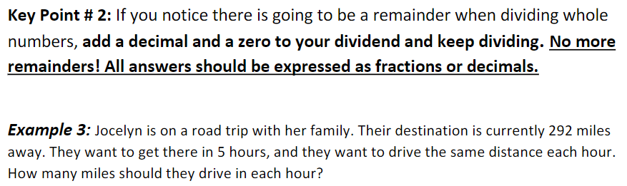
- Teacher MODELS example 3
- Students COMPLETES model 4
- 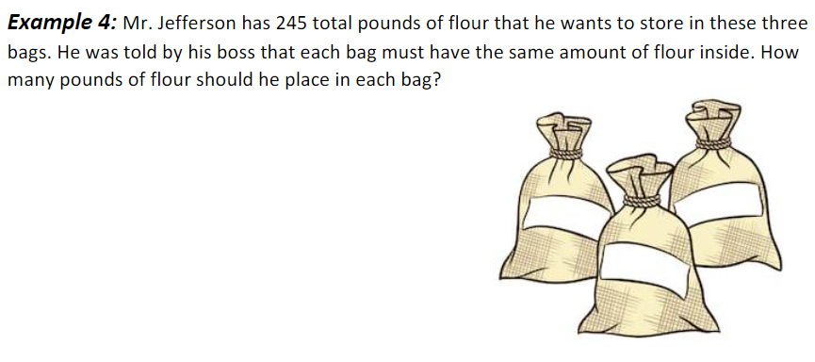
GP: Guided Practice (We do)
- Students work with elbow partners to complete the following examples
- 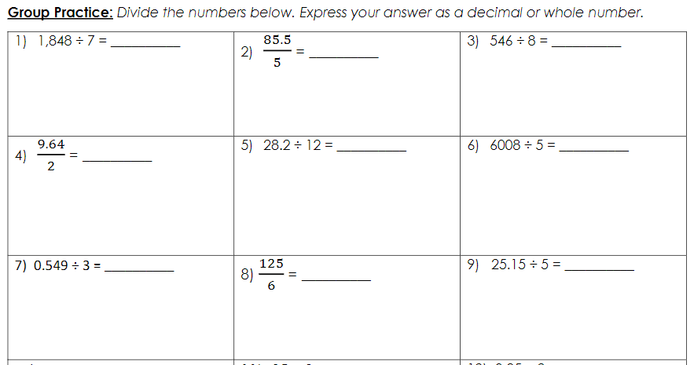
- 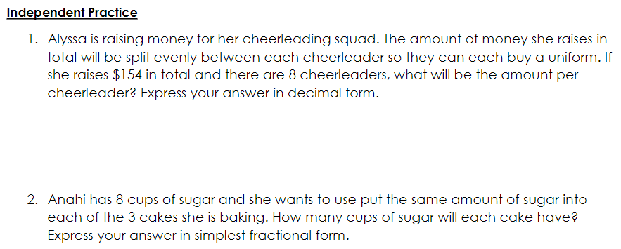
Instructional Input - Synchronous
AS: Anticipatory Set (Introduction)
- Students practice long division with NO remainders. As students are practicing, ensure to be circulating and monitor students are dividing correctly using the long division method. Bring class together if the same mistake continues to happen to review whole class
M: Modeling (I do)
- Teacher MODELS example 1
- 

- Students complete example 2
- 

- 
- Teacher MODELS example 3
- Students COMPLETES model 4
- 
GP: Guided Practice (We do)
- Students work with elbow partners to complete the following examples
- 
- 

Independent Practice/ Homework
- 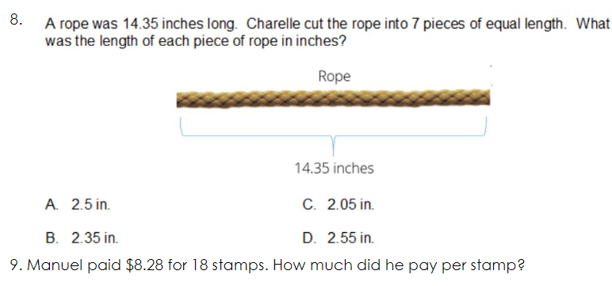
- 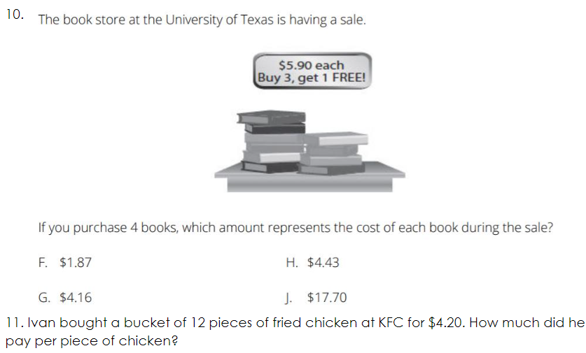

Additional Practice
- 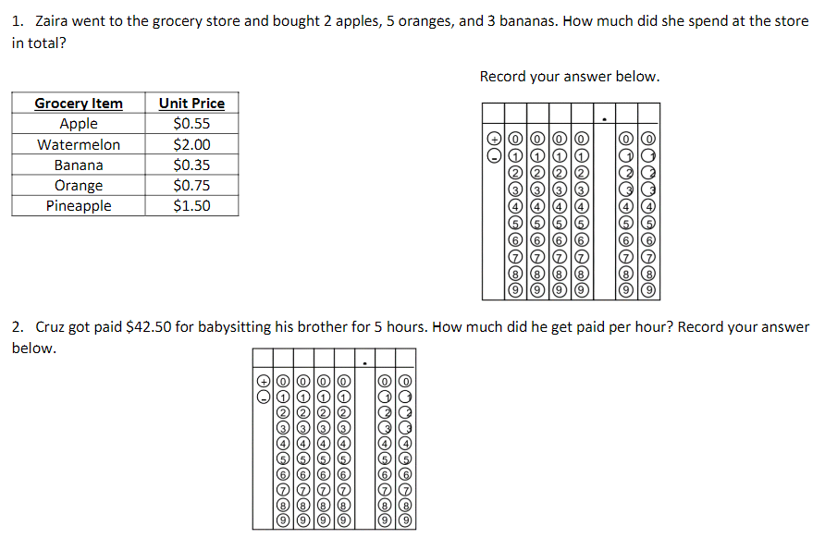

Lesson Close

Learning to multiply and divide with decimals is an important skill. In both cases, you work with the decimals as you have worked with whole numbers, but you have to figure out where the decimal point goes. When multiplying decimals, the number of decimal places in the product is the sum of the decimal places in the factors. When dividing by decimals, move the decimal point in the dividend the same number of places to the right as you move the decimal point in the divisor. Then place the decimal point in the quotient above the decimal point in the dividend.

